Easy Read and Visual Synopsis
Purposeless Movements
Edinburgh International Festival 2019

Funny and challenging in equal measure, the show mixes up music, video, movement and text as four guys tell funny and moving experiences of their purposeless movements - a medical term that comes from describing cerebral palsy.

The show is accompanied by music performed live on stage.

It is captioned throughout with text projected on the red wall at the back of the stage and the BSL interpreter, Amy, moves around the cast at all time providing translation for Deaf audience member and being a performer with the rest of the cast.

Some things to know about the show:
- There are a variety of lighting effects including projection on the back wall of the set
- Lighting effects within the show include moving spotlights and a very strong light that glares out at the audience at the end of the show - for around 1 minute and then at the end for around 30 seconds.
- Sound effects include lots of effects within the music and distortion of guitars etc
- The show is generally quite loud and the music is intentionally overpowering

Cast

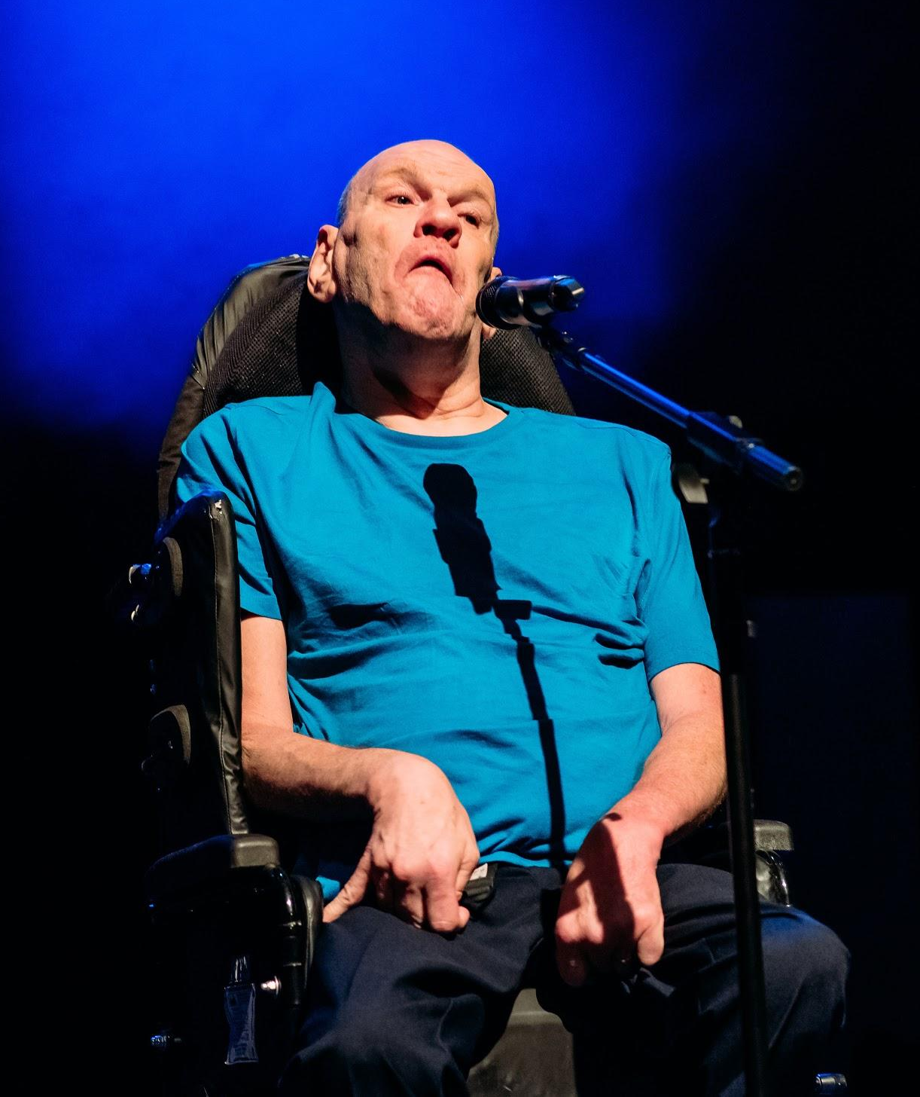
Pete - Turquoise short sleeved t-shirt.
Dark blue trousers. Grey trainers.

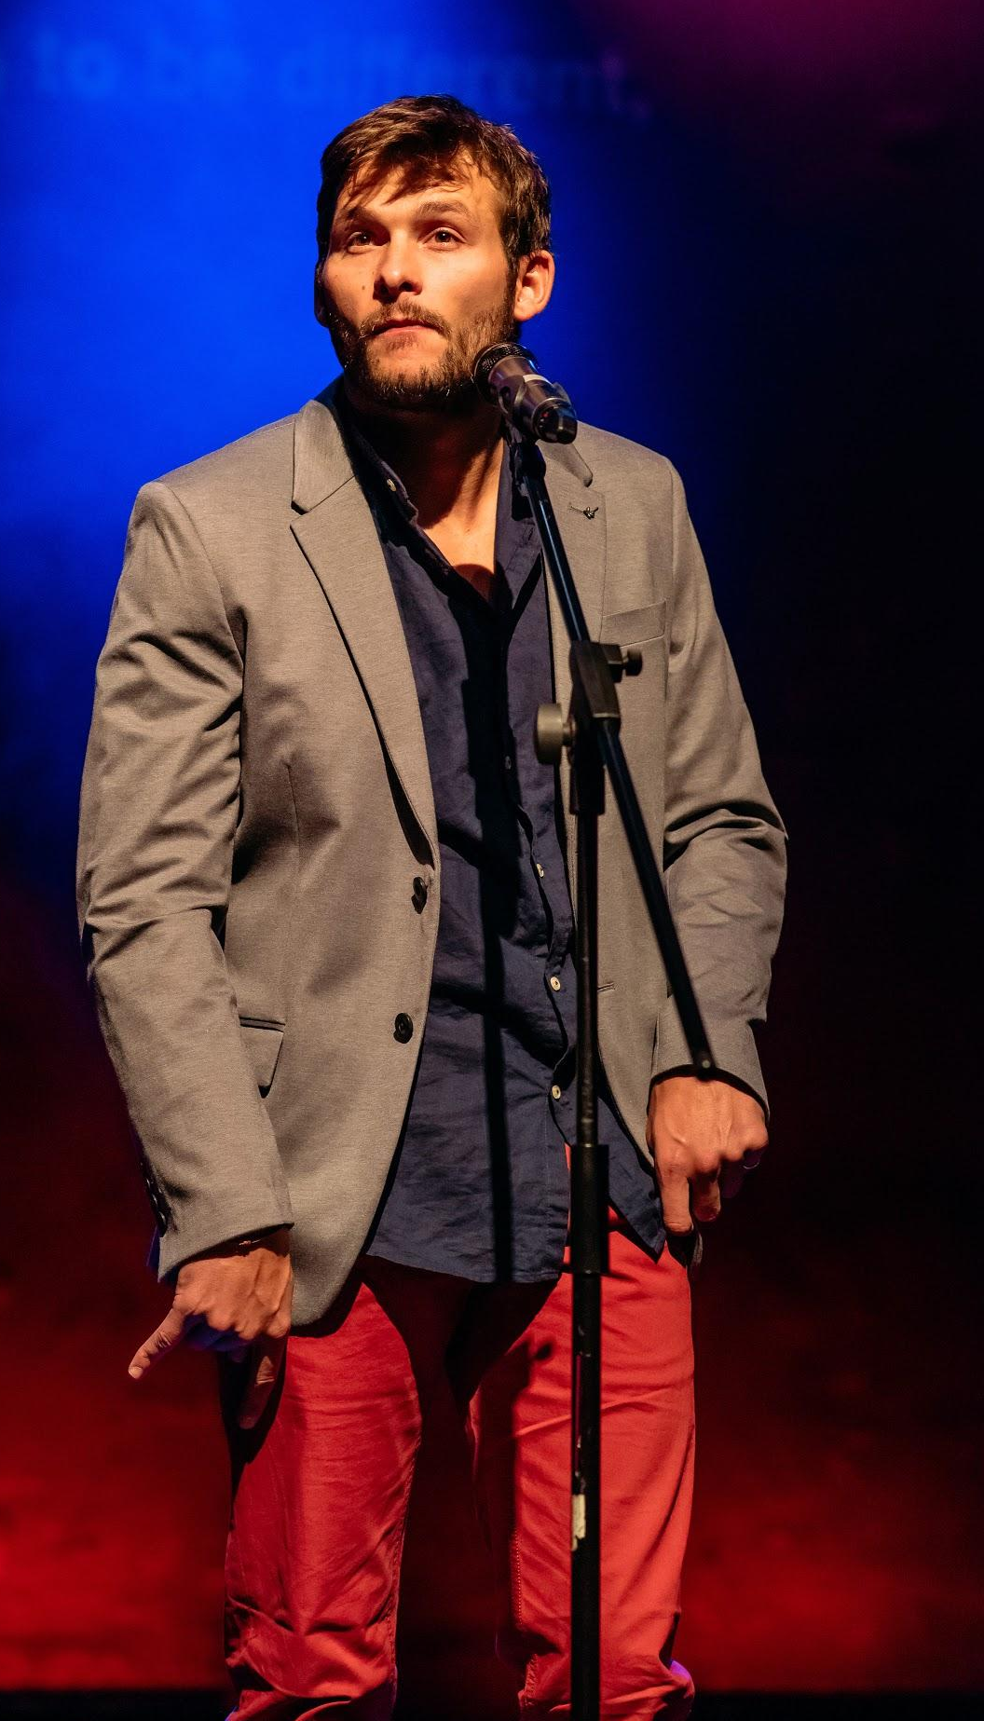

Phil - Dark blue shirt with buttons down the front. Grey jacket. Red jeans.
Dark trainers with orange laces

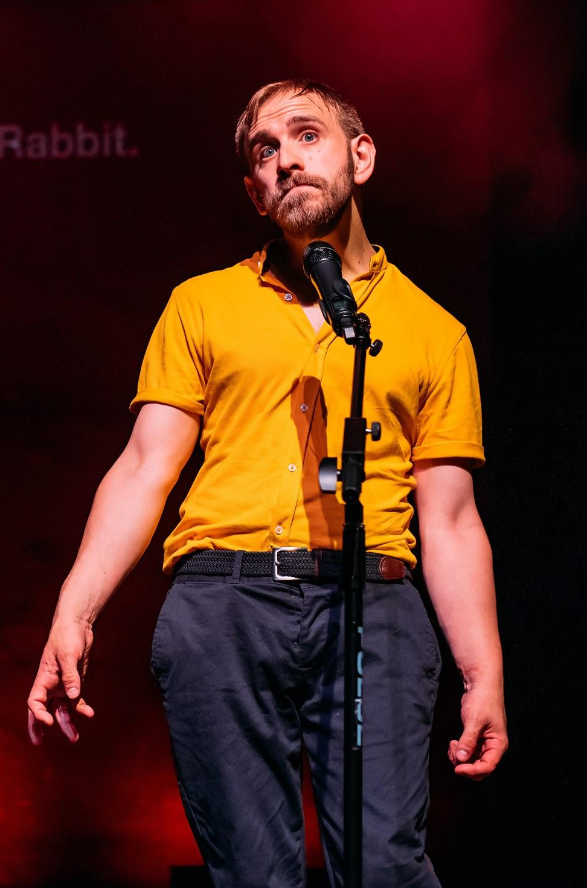

Colin - Ochre yellow short-sleeved polo shirt with collar. Navy trousers. Burgundy trainers.

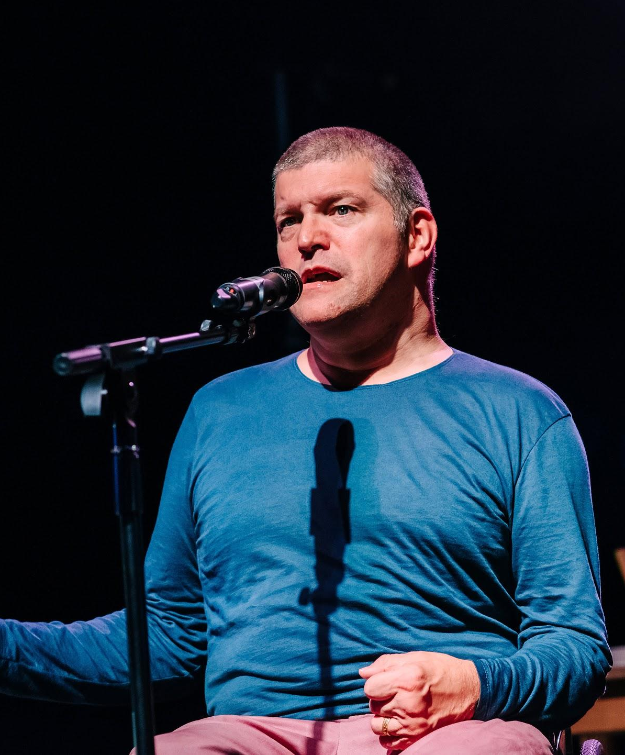

Laurence - Mauve trousers. Navy long-sleeved top. Blue jacket. Navy trainers

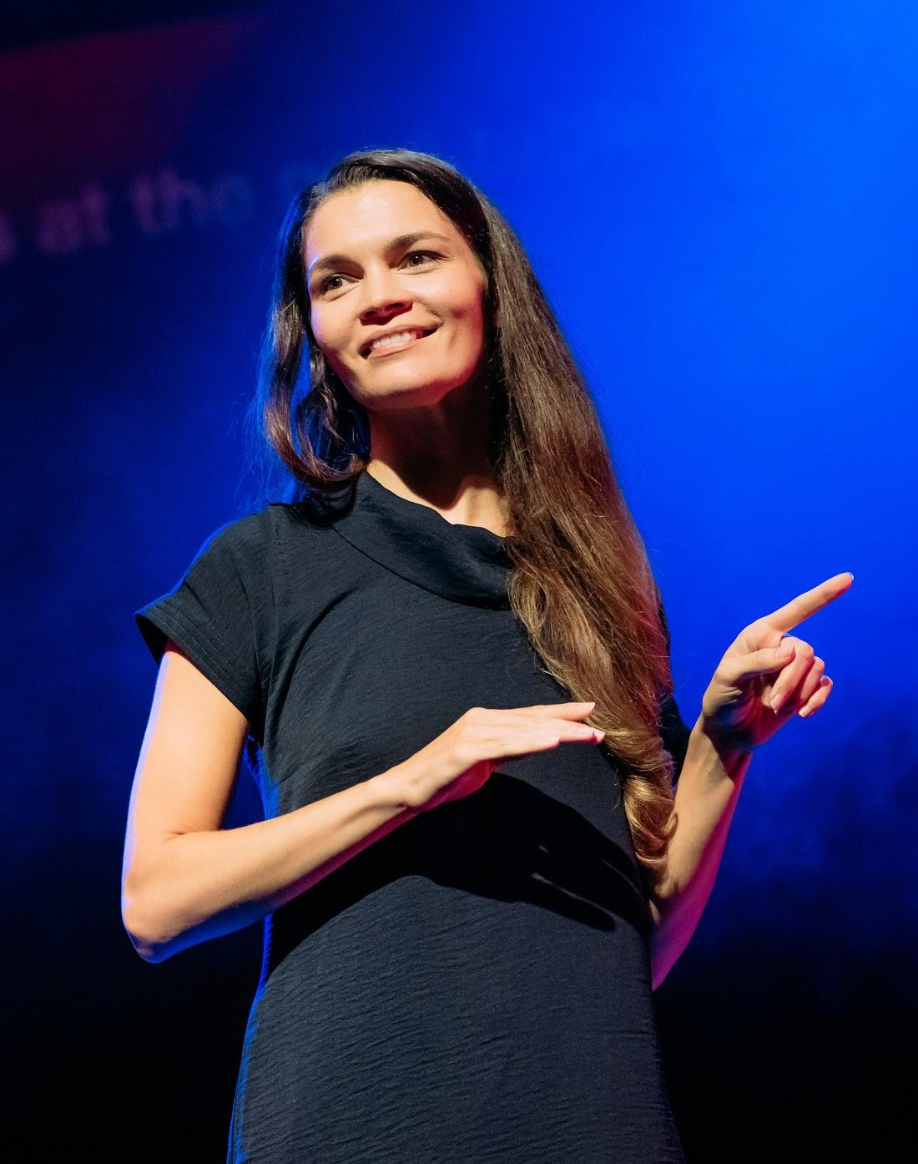

Amy BSL interpreter - Navy knee-length dress,
short sleeves and a collar. Ochre trainers.

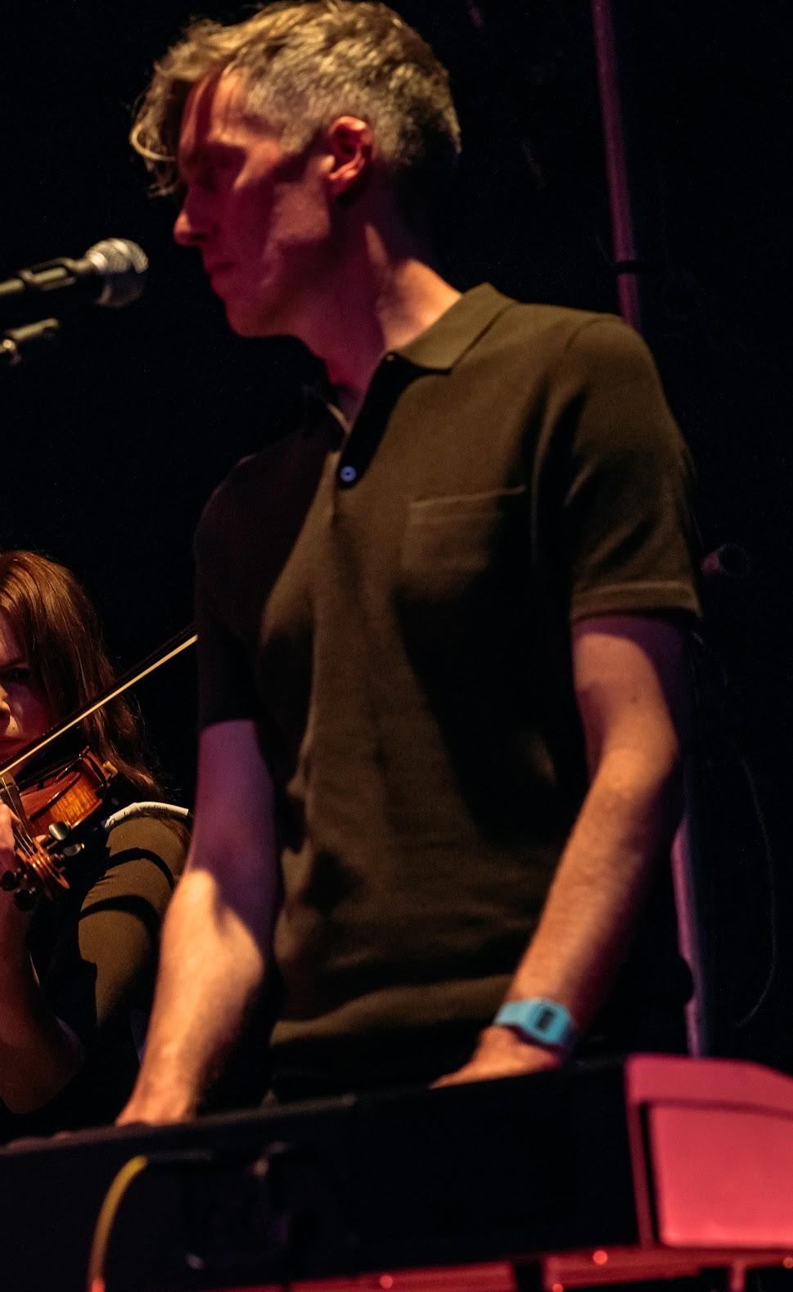

Scott Musician and Singer - Dark olive short-sleeved polo shirt with collar. Black trousers

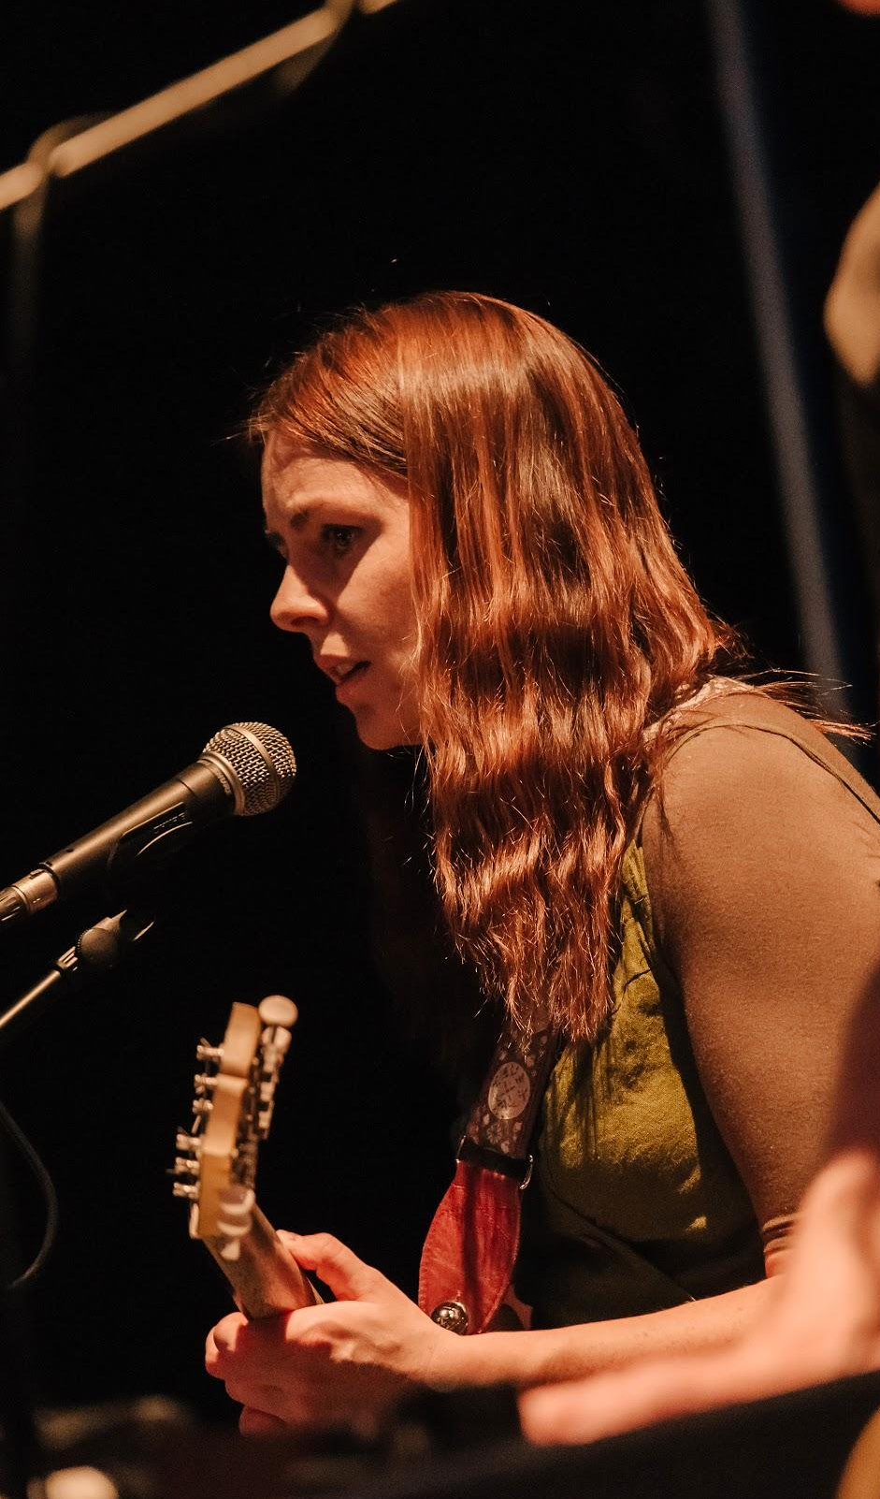

Jill Musician and Singer - Olive coloured dress with similar coloured long sleeved t-shirt beneath

The Performance

The house lights fade to black. Darkness.

Colin, Laurence, Phil and Pete enter and face us, with their backs to the wall.
They strike and hold dramatic poses.

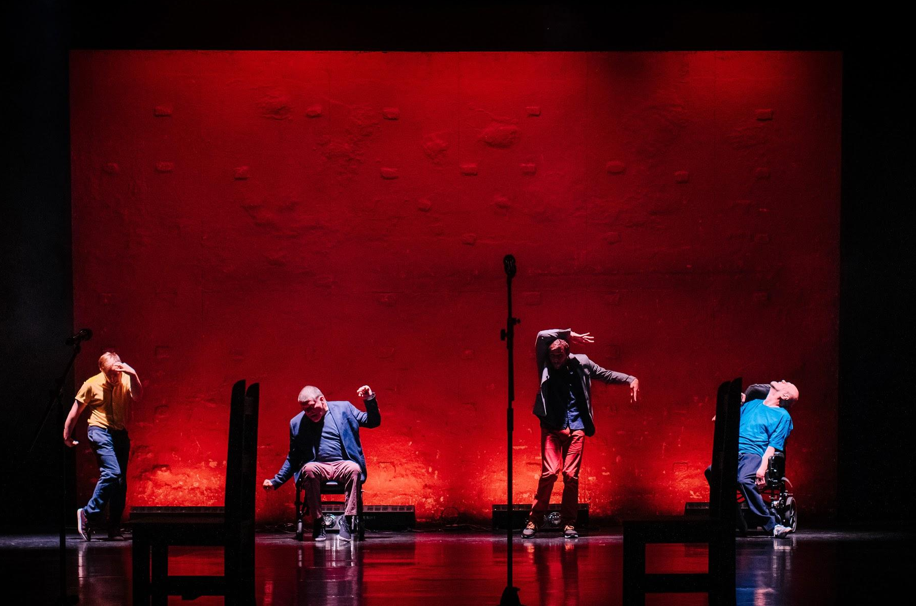

They all move forward and Amy, the BSL Interpreter joins them and moves the mic towards Pete’s mouth.

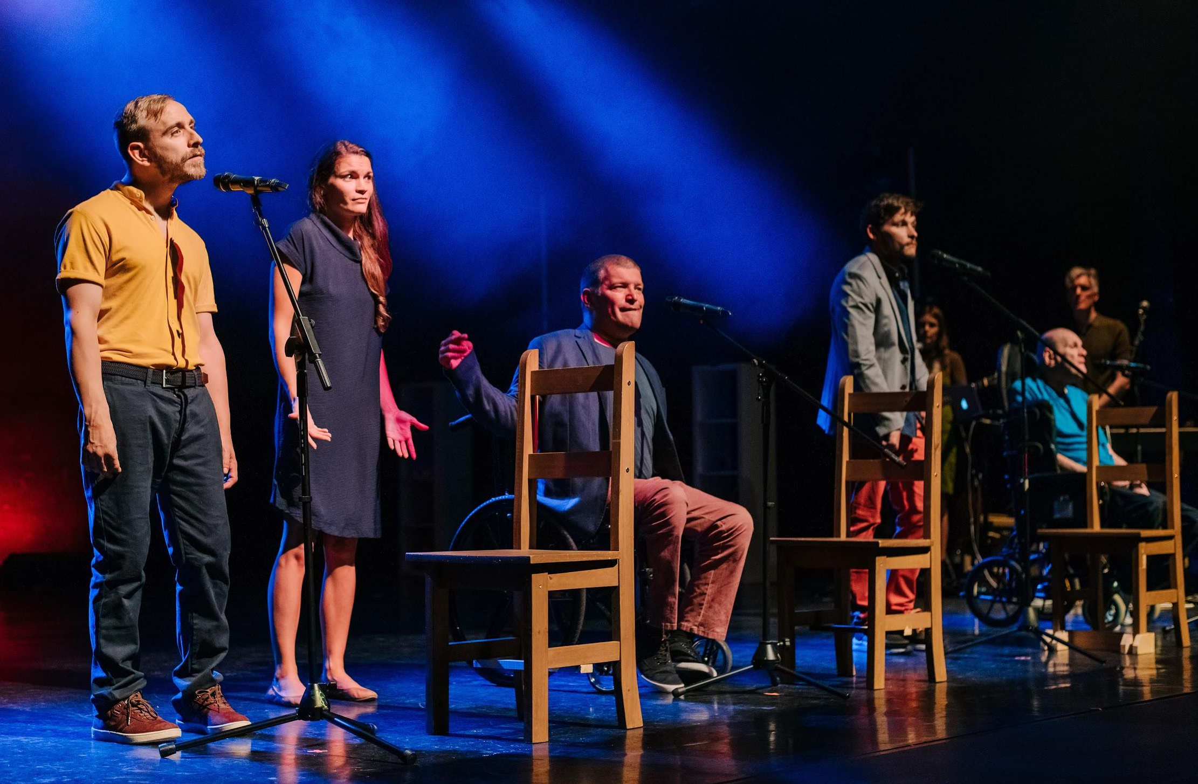

All of us are professional actors – we’re not just doing this for kicks.
We’ve spent years being paid to talk on stage.
I mean – fuck sake – we get paid to speak!
You’ve got to be having a laugh.

I’m Colin
I’m Lawrence
I’m Phil
I’m Pete.

They move to the back of the stage and then fight over a mic to tell us facts about cerebral palsy.

Phil sits on a chair right at the front of the stage so he is close to the audience. He takes off his jacket and tells us a story about a girl at school

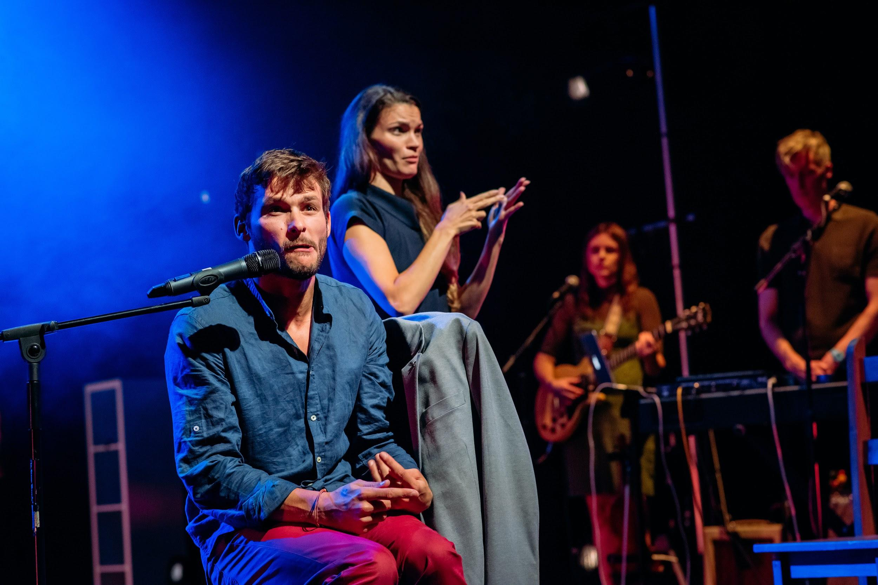

Phil beckons her towards him with a cock of his head. She moves closer. They play out helping phil to dress and eat.

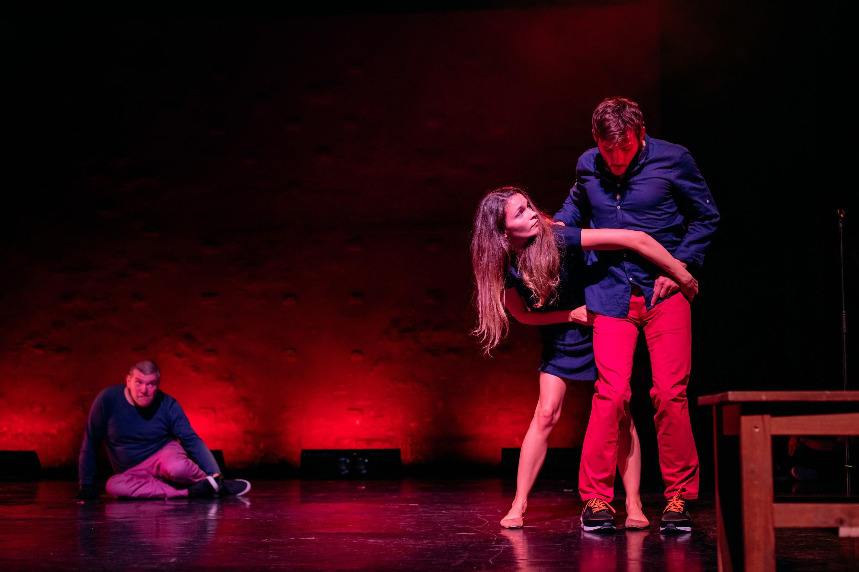

Amy curls up tenderly, draping her arms around Laurence. He crawls from the right of the space to the centre.

Colin is gazing into the lens of a camera in one of the bookcases on the right. His face is projected onto the rear wall so it is seen larger than life as he talks about being diagnosed with CP as a child
He asks “But what does it really mean? Which of my movements have no purpose?”

The guys line up. Those who can do it, step forward on command. We hear an unseen voice.
Text on screen: Good evening gentlemen. Can you dress yourself? The voice goes on task lots of questions

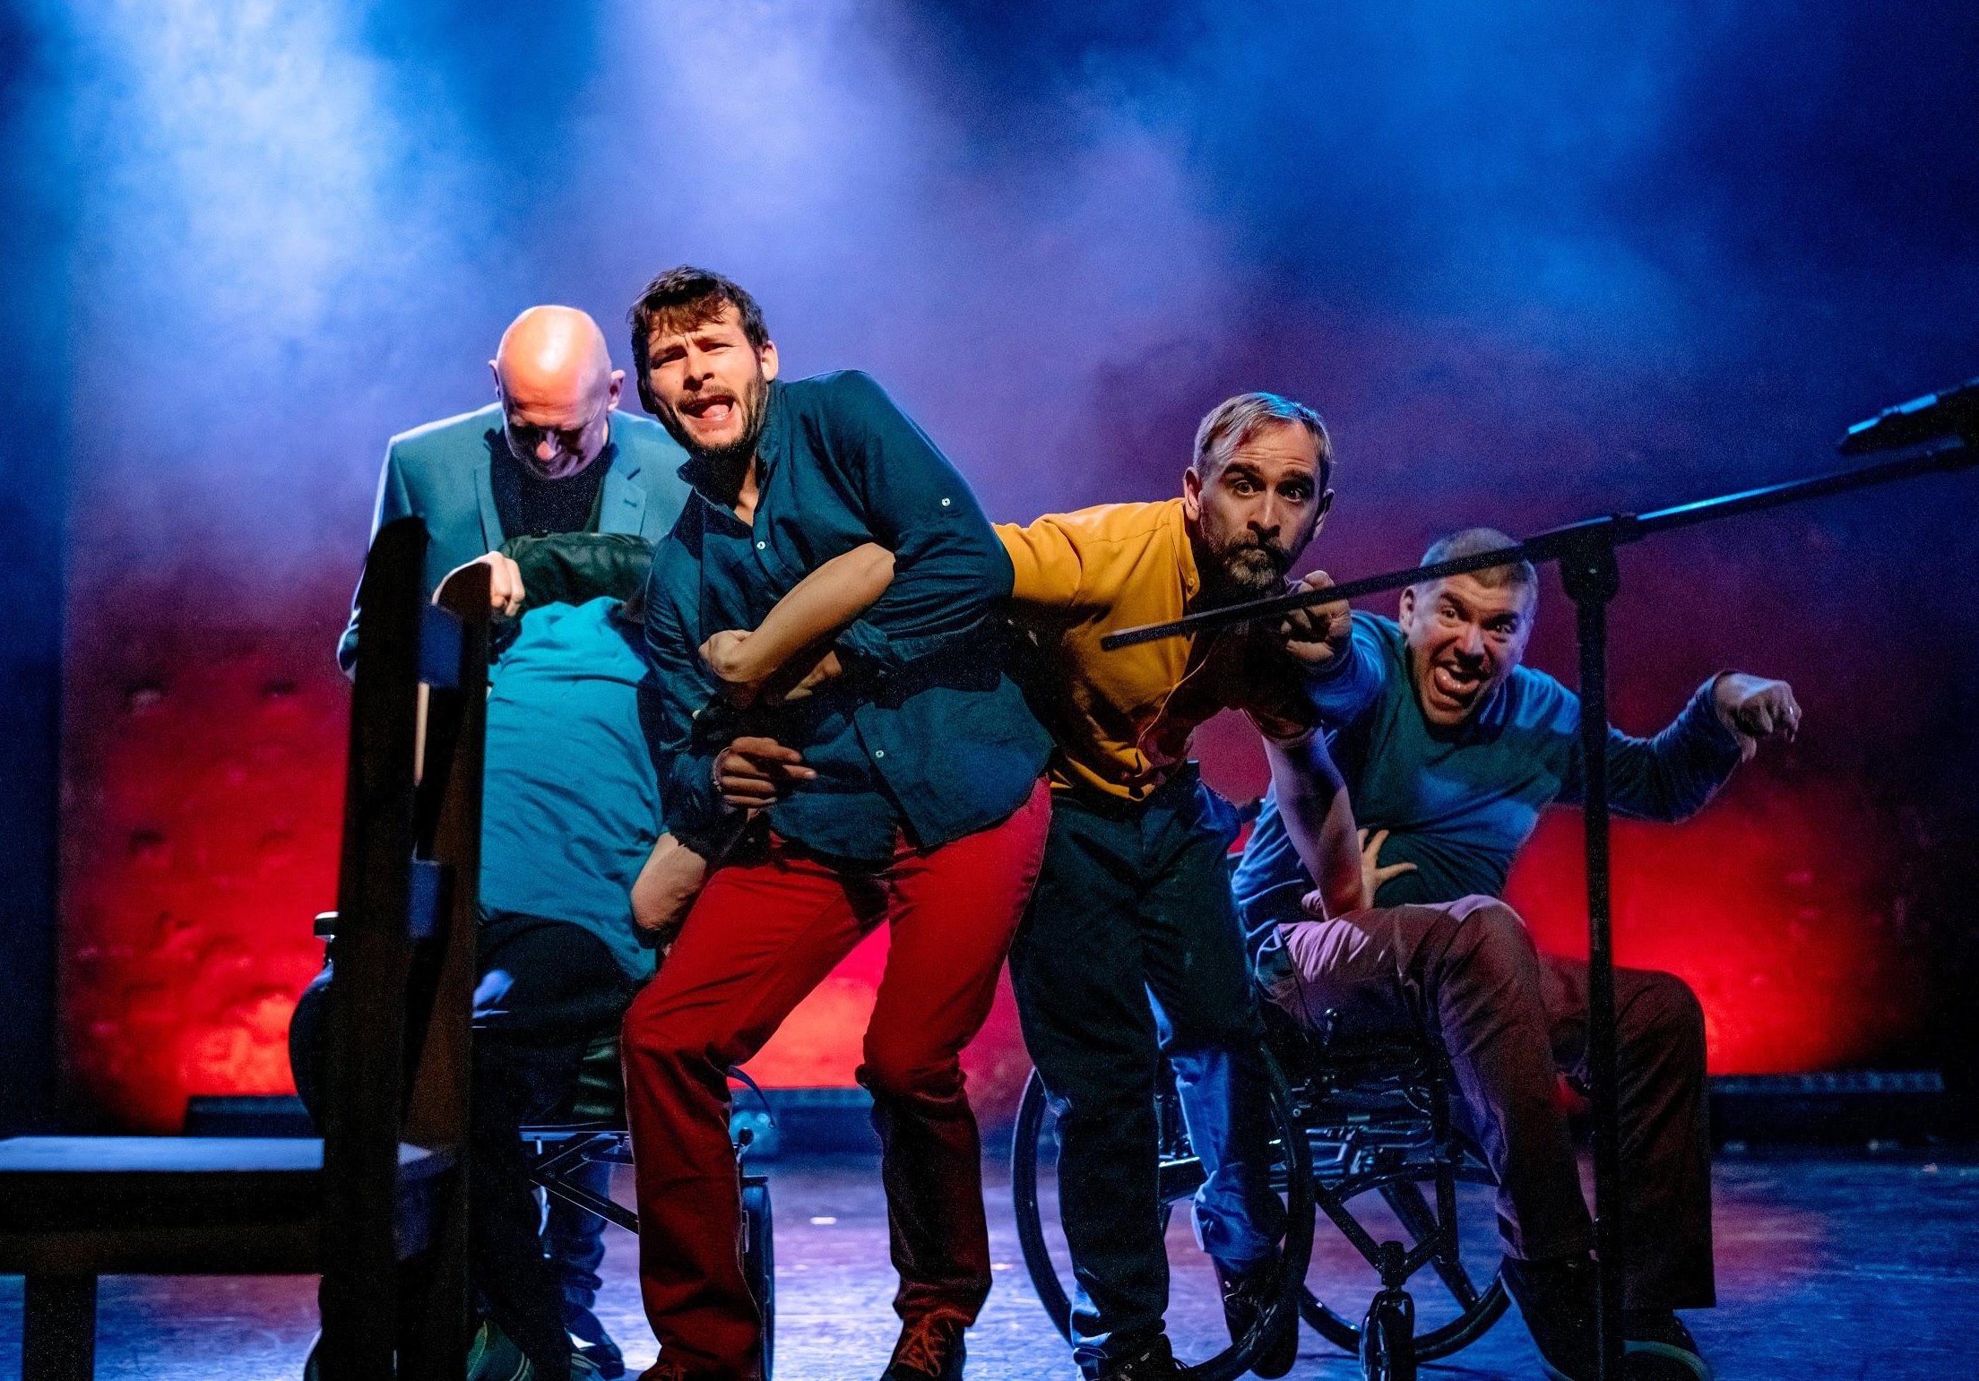

The lights go down on them. They stop fighting for a place and move apart.

Phil brings out a football. He and Colin have a kickabout at the back of the stage.
Laurence at the very front turns to the audience to talk about his occupational therapist.

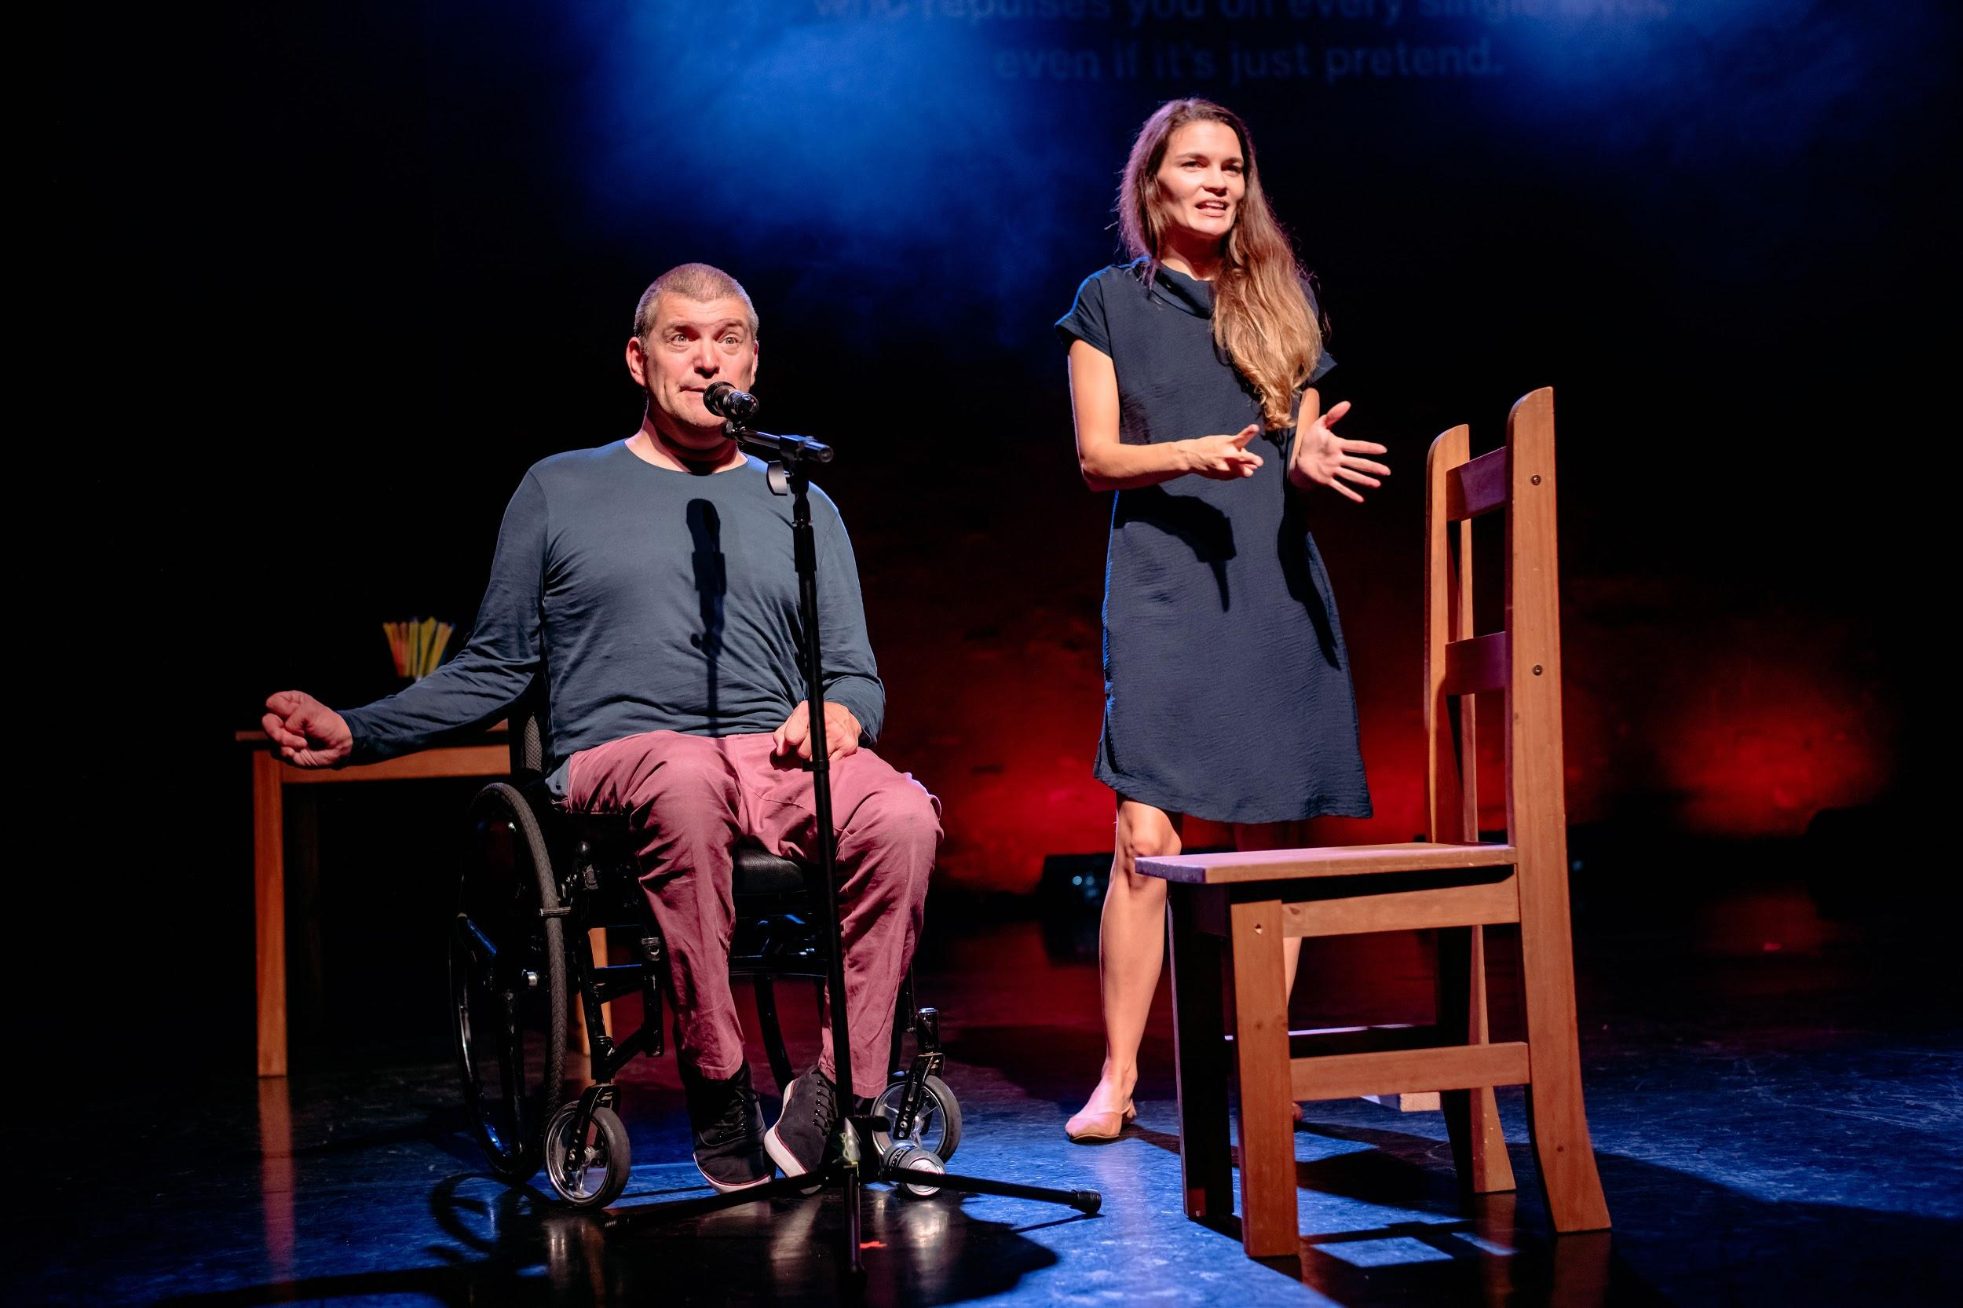

Colin rolls a can of beer towards Laurence and dishes out to the rest.

Phil, Colin, Pete and Amy ask audience members to open the cans of beer. Froth spills from the cans.

The guys all lift their chairs and position them around a small wooden table, on the left of the stage. On it is a folded-up tablecloth, a pot full of multi-coloured straws and four small plates.

Colin is flirting with Amy. He tries to impress her with his feats of strength, lifting the microphone stand over his head and pretending it is a heavy weight. Phil intervenes, wags his finger at Colin, and ushers him over to the table.

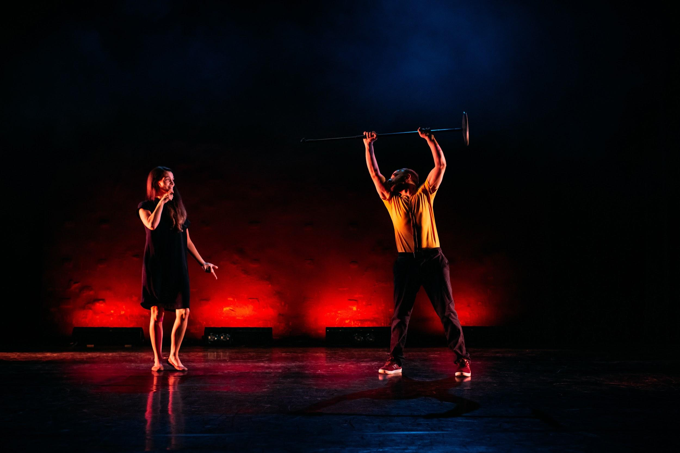

The guys gather round the table and begin an anarchic dinner party.

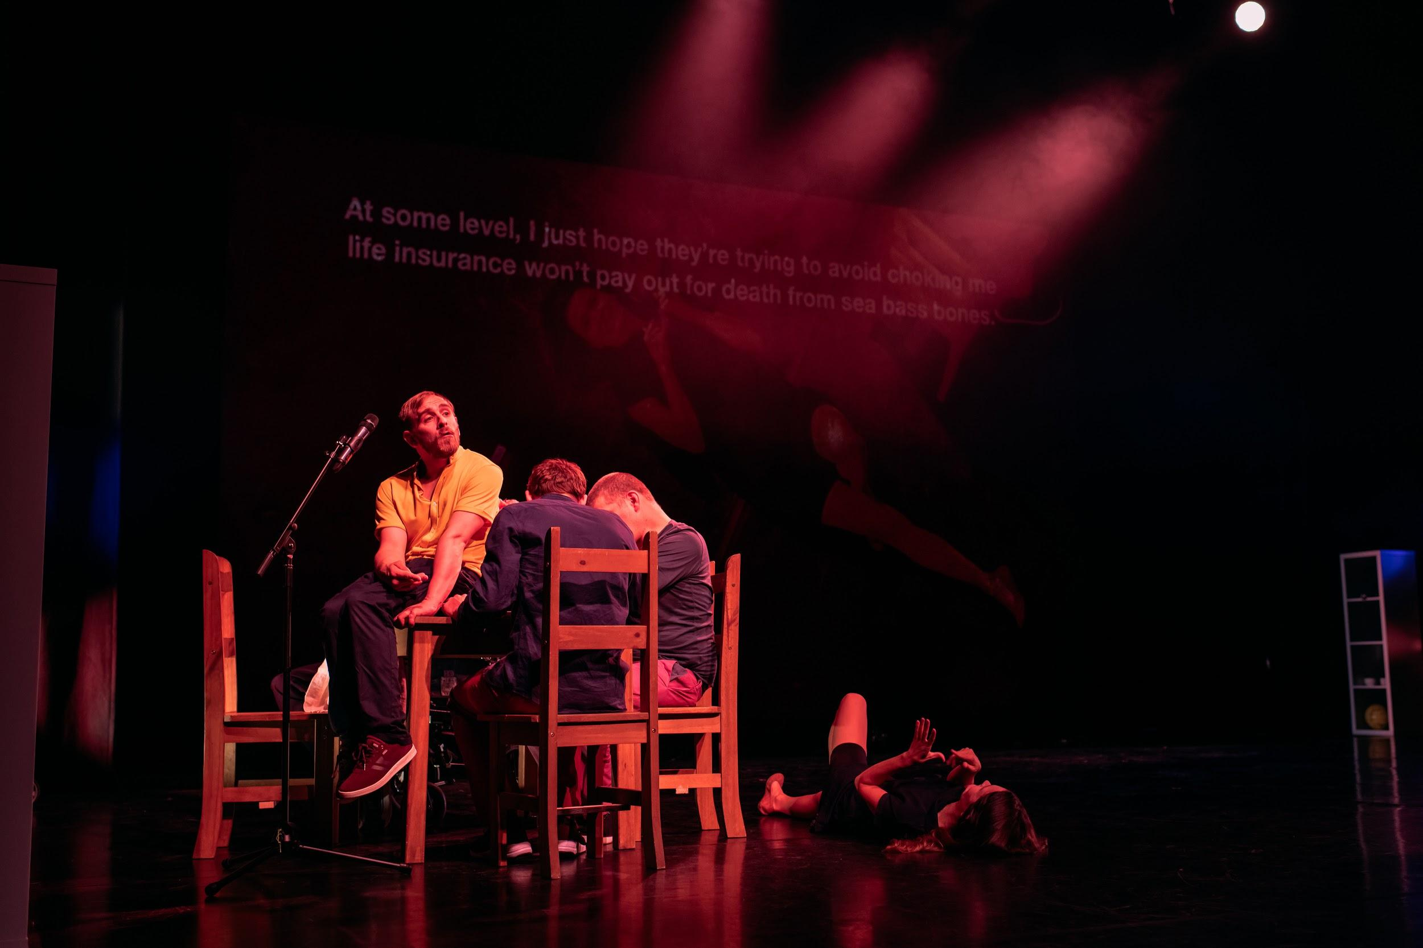

Colin slowly paces away, cradling a baby wrapped in a blanket. Amy curls up on Pete’s lap, clutching his chest, resting her weight on him as he slowly moves them across the stage. He arrives at his microphone and she gently detaches herself from his lap and stands beside him.

All four men line up in a row of microphones and sing before telling jokes.

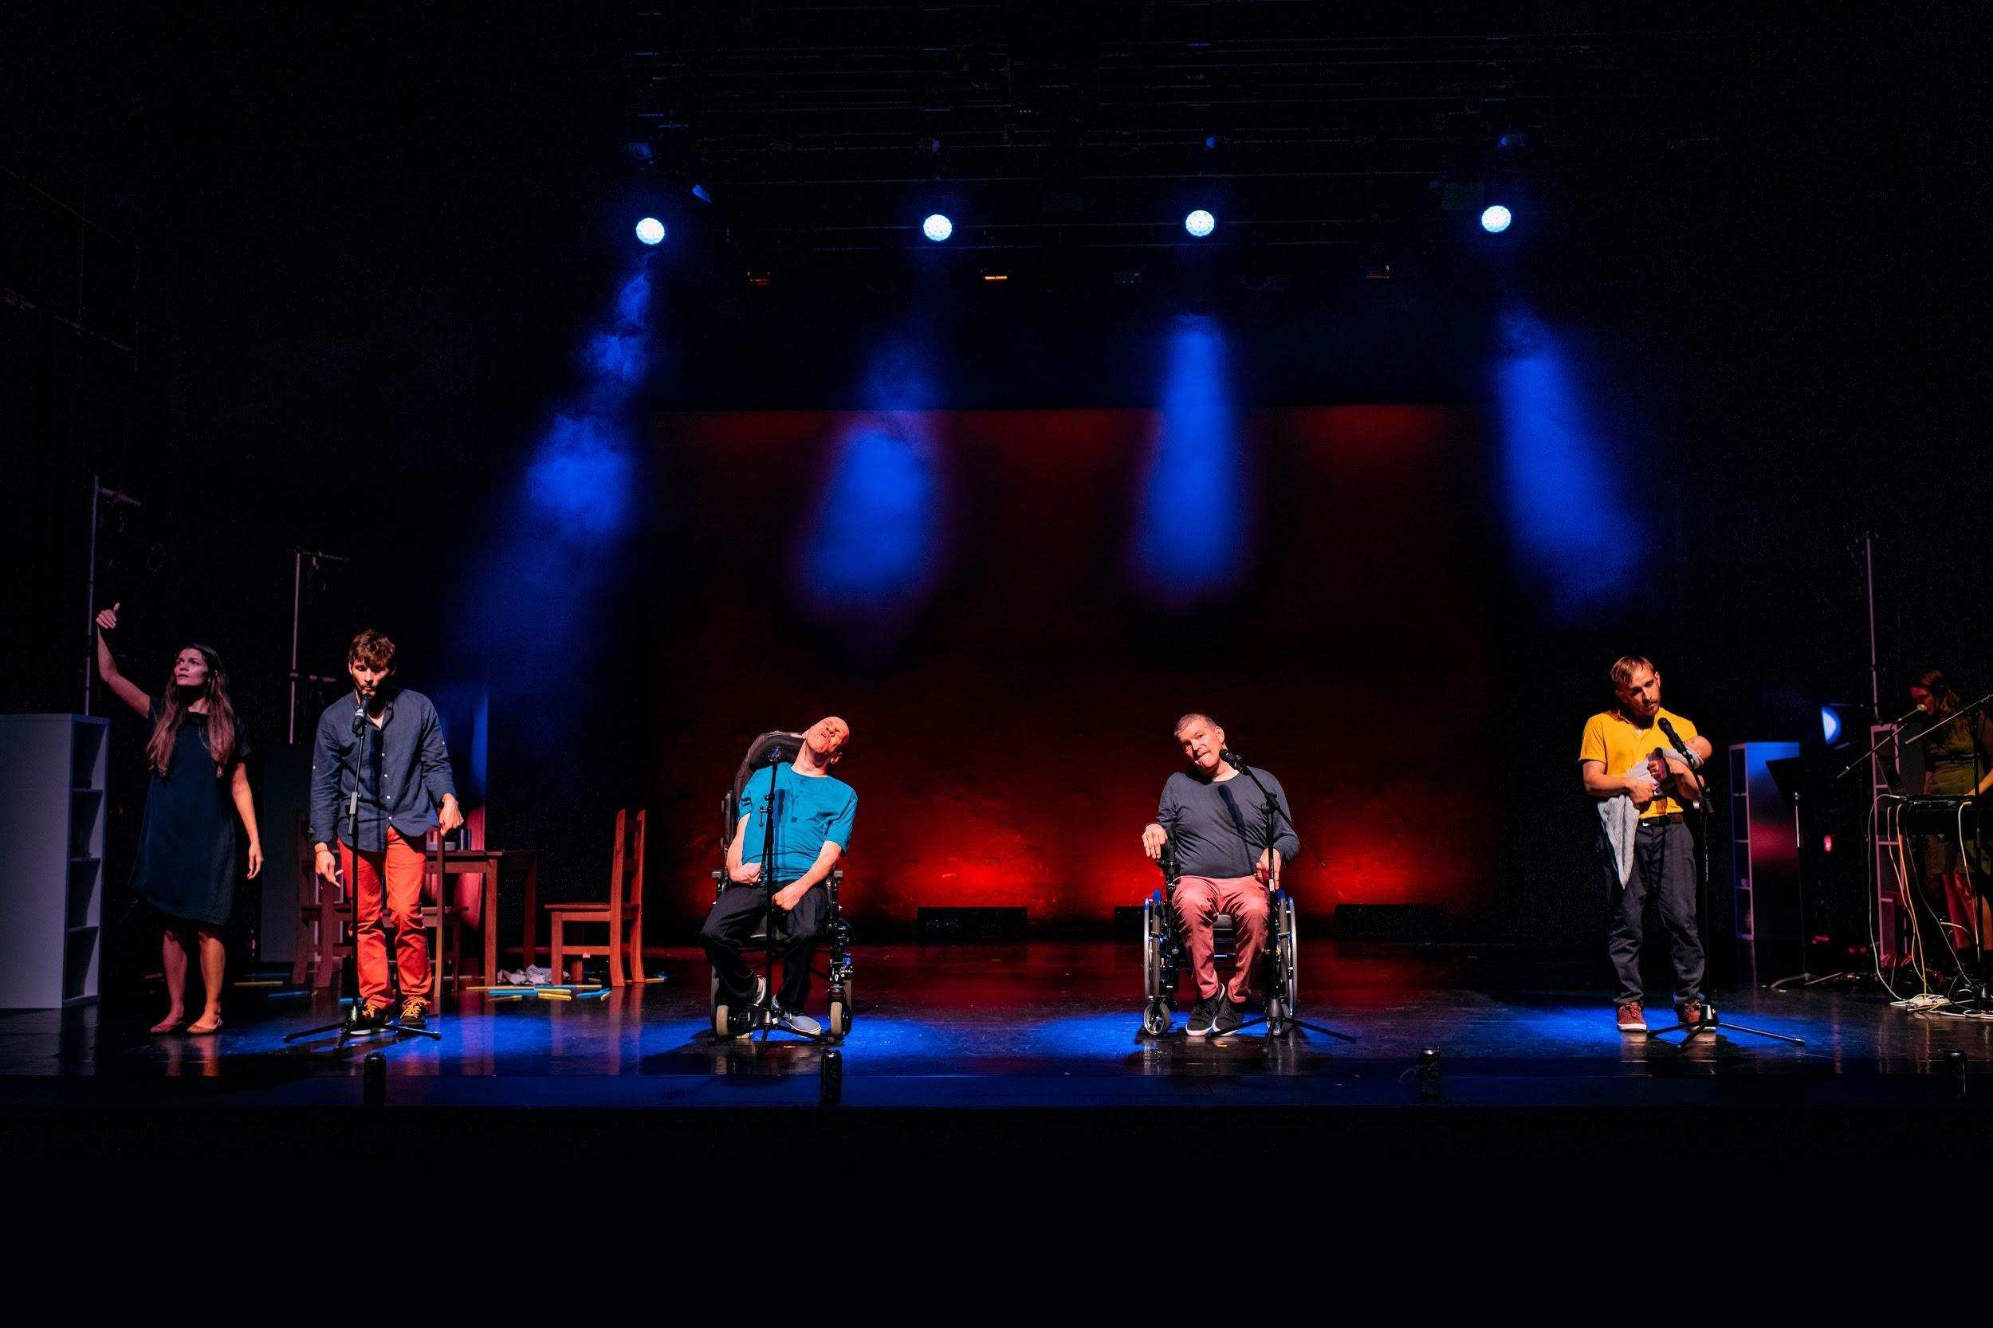

Colin and Phil face each other, across the room. Colin holds out his hand to shake, then pulls his arm away, pivoting on the spot. He repeats until he reaches Phil, who holds out a microphone for Colin to take. Colin talks about a job he has. “I sit on a government advisory body for disability equality – have done so for three years.” He is not taken seriously in the job and is patronised.

Colin steps back and is grabbed by Phil. He begins to mould him, like clay, forcing him into a different pose. All four guys for Colin into different positions until he breaks away.

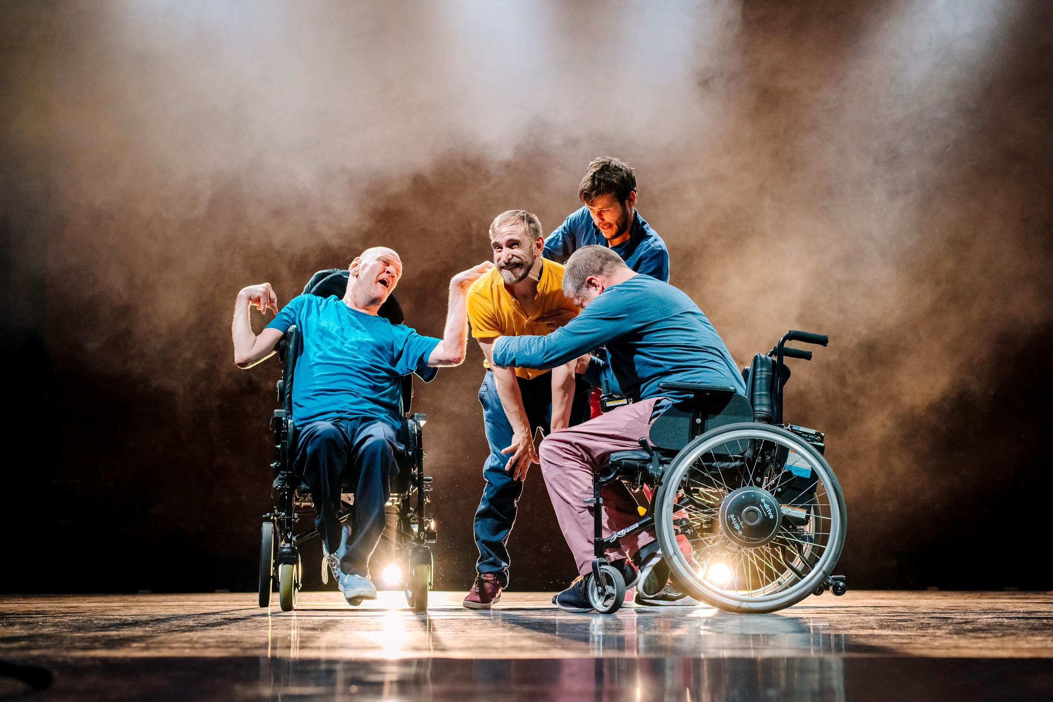

The stage goes dark - Blackout. Each of the men takes himself off to a quiet corner has a rest and some water.

Video of Pete’s dangling, naked feet. They appear weightless, his toes gently twirling as if floating in space.

Laurence talks about his speech impairment and getting away with introducing someone when you can’t remember their name! Amy and Scott help give an example. Colin and Pete then talk about Colin not understanding something Pete had said in the past.

Colin and Laurence orbit Pete, in alternative directions.

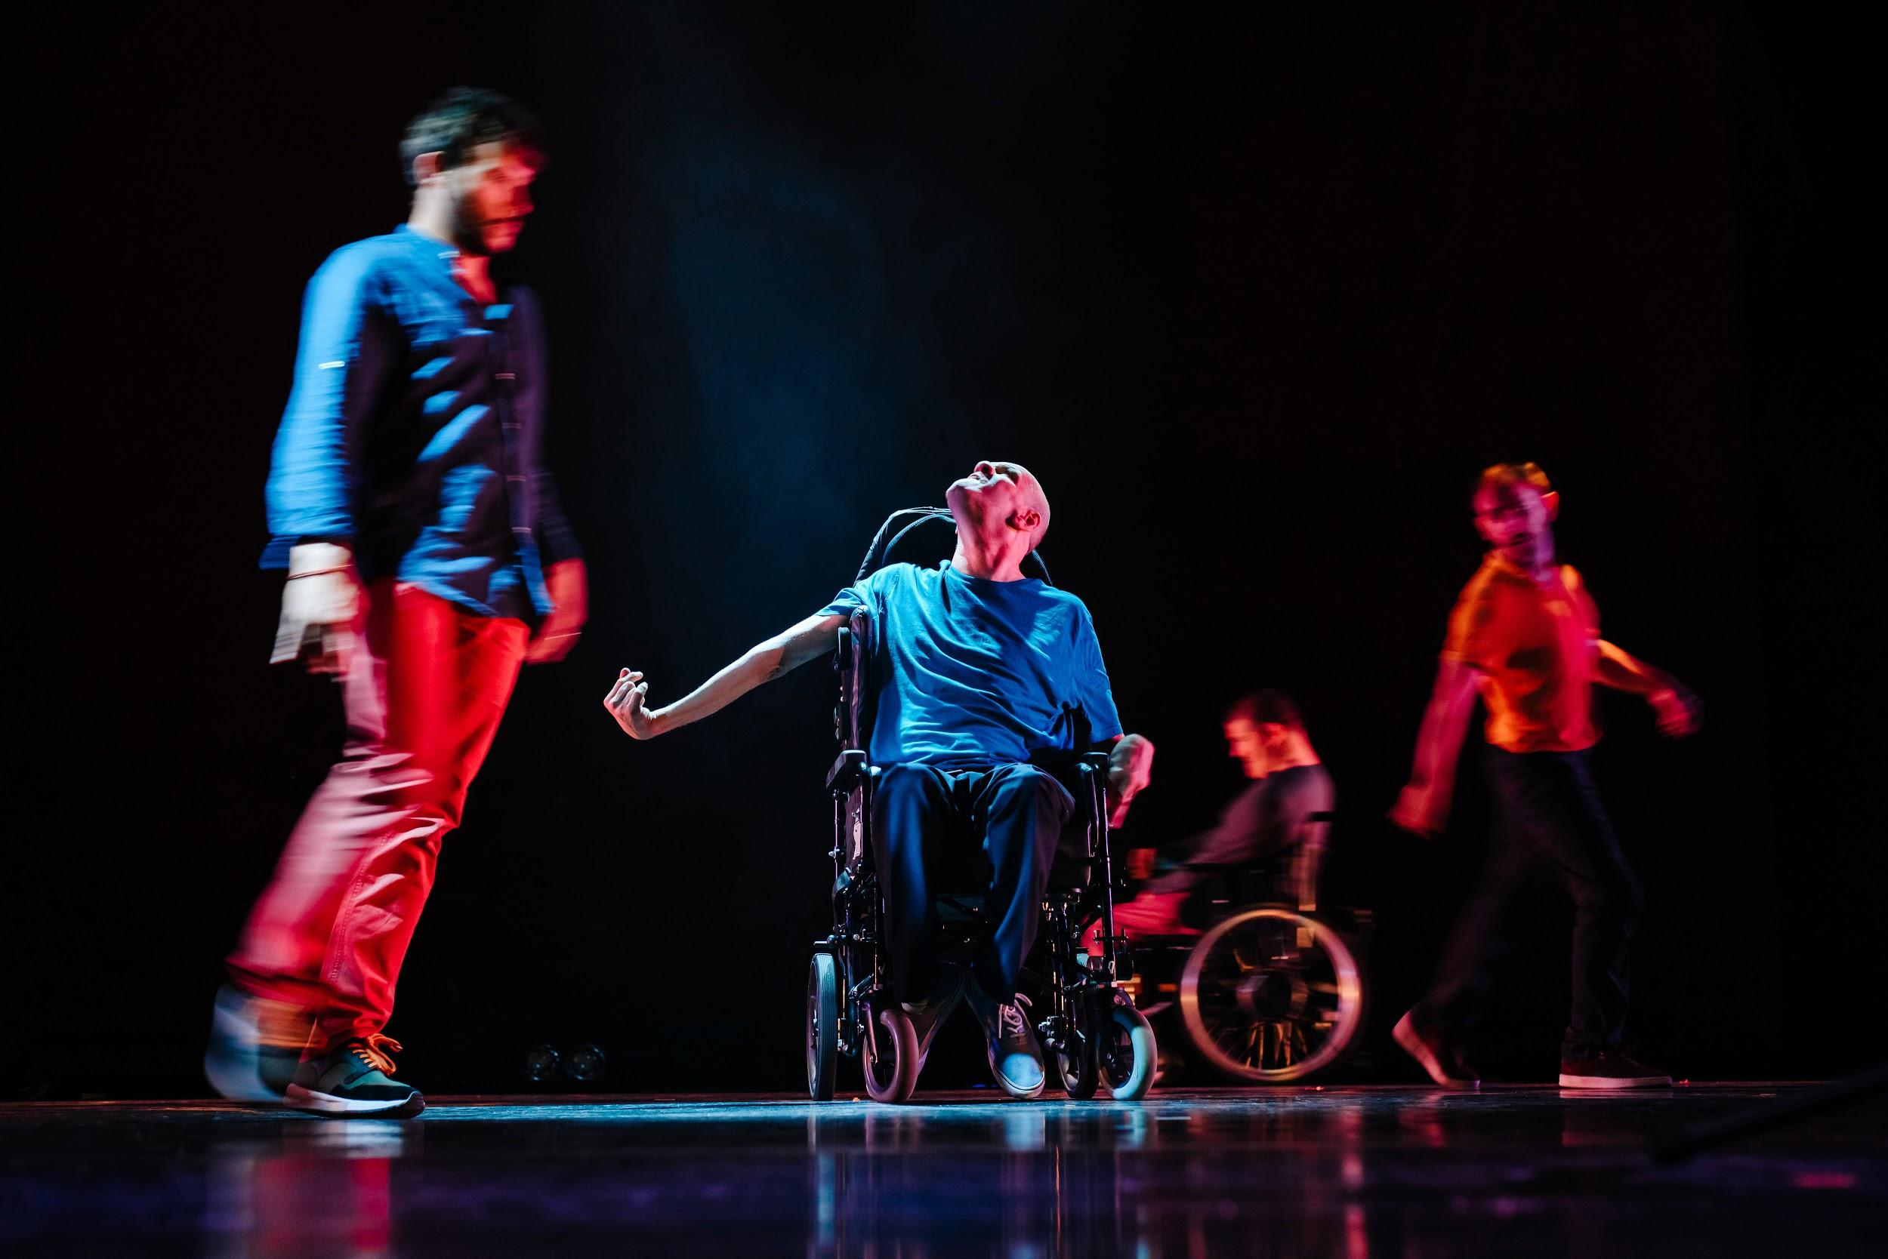

A video of Pete takes up the whole of the back wall the wall. As the video plays Pete removes his shoes and socks on stage very slowly and with great effort using his feet.

The guys all talk about voices and not understanding what people say and their voices not sounding like they do in their heads.

A cushioned black vinyl matt is placed in front of Pete and he slides out of the wheelchair and lowers himself onto the bed. Kicking his legs and arms, he rolls himself onto his back. On the wall we see his wriggling body in live feed from above. Laurence and Phil join him on the matt. Amy gently places the microphone on the matt inform of Pete and raises his head to speak.

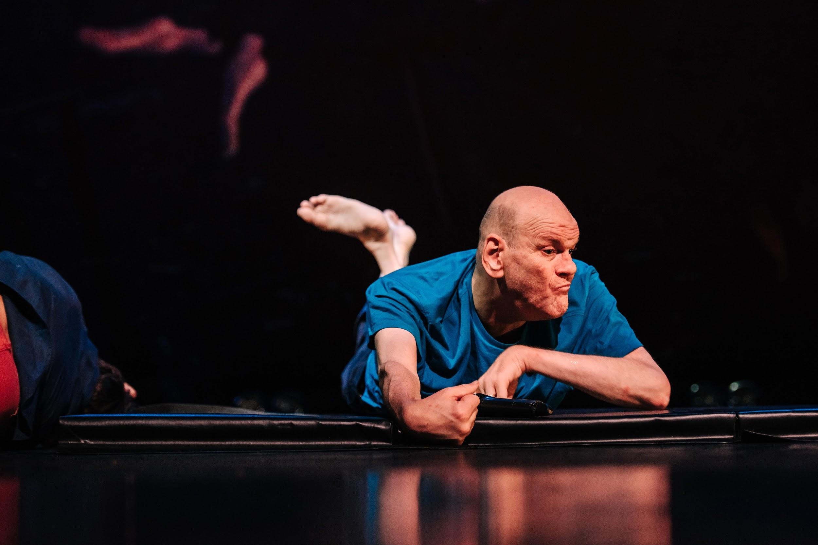

Pete moves himself to the back section of matt. The mat is ripped in two. One piece is removed and lifted off. The other, with Pete still upon it, is dragged off.

Laurence wheels to the back of the space. Amy helps him out of his chair and, holding her hand, he takes a few steps before kneeling on the mat.

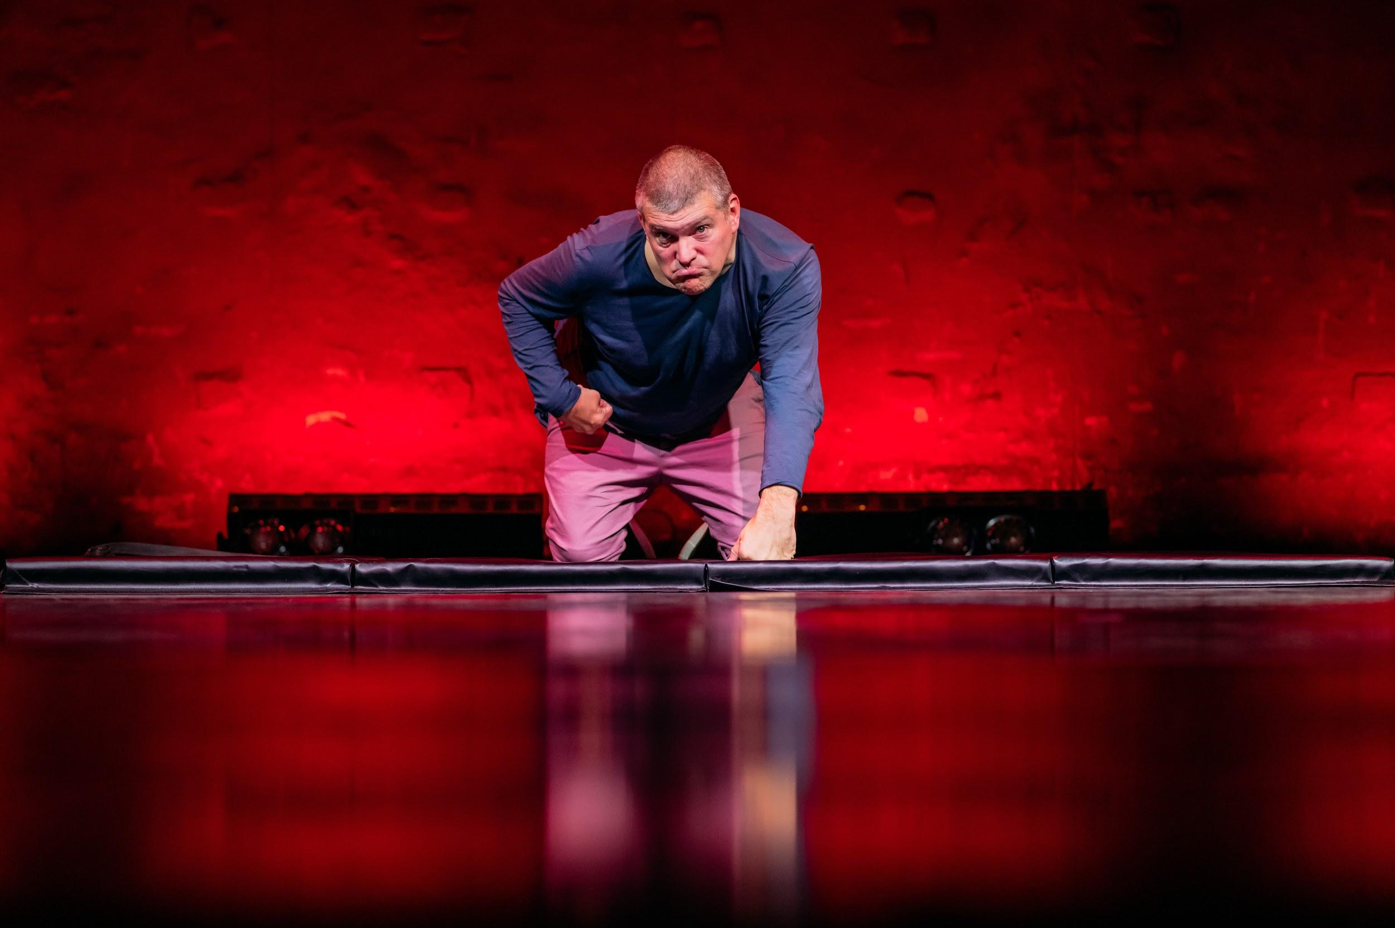

Two chairs face each other and Phil and Colin face each other and then Laurence and Colin.

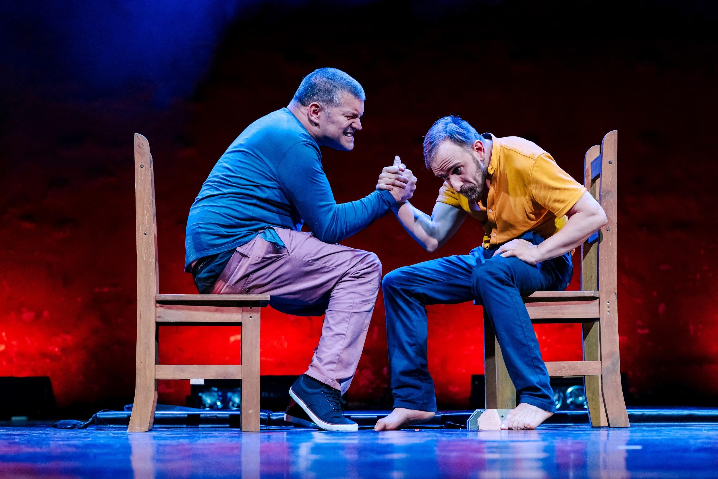

Pete, Laurence, Colin and Phil fan out across the stage. With no warning a shop-bought sandwich drops from the skies and lands beside each of them and each of them begin to grapple with the packaging.

Laurence and Pete turn to face each other and they all begin to fight.

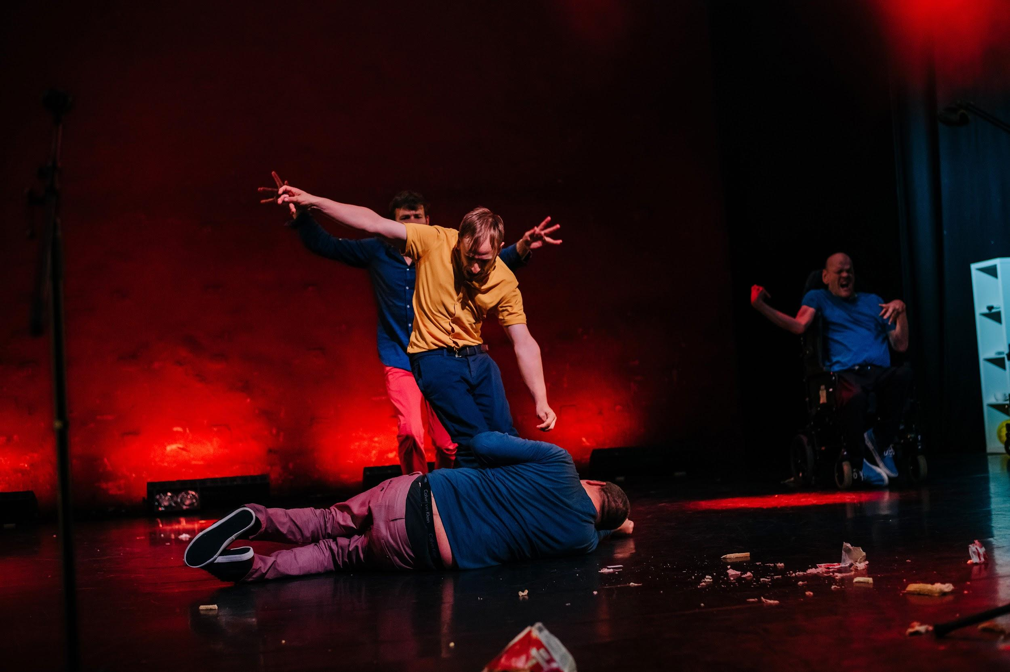

The guys start to break apart from their fighting and begin to move in time to the music. Anger gives way to euphoria and they dance in swiveling lights, gentle rainbow colours washing over them in a disco swoops. On the wall is video of kittens and cats with cerebral palsy starts playing.

Phil drops to the floor and crawls with effort towards a chair. He hauls himself upon it his hands twisted. He sits on the chair. He straightens up. He gets to his feet and walks casually to the table. He sits perched on its edge, completely still, legs dangling gently. The others stop dancing and look at him. Laurence breaks into a grin. Phil picks up a chair, walks over and places it beside Colin, who sits on it.

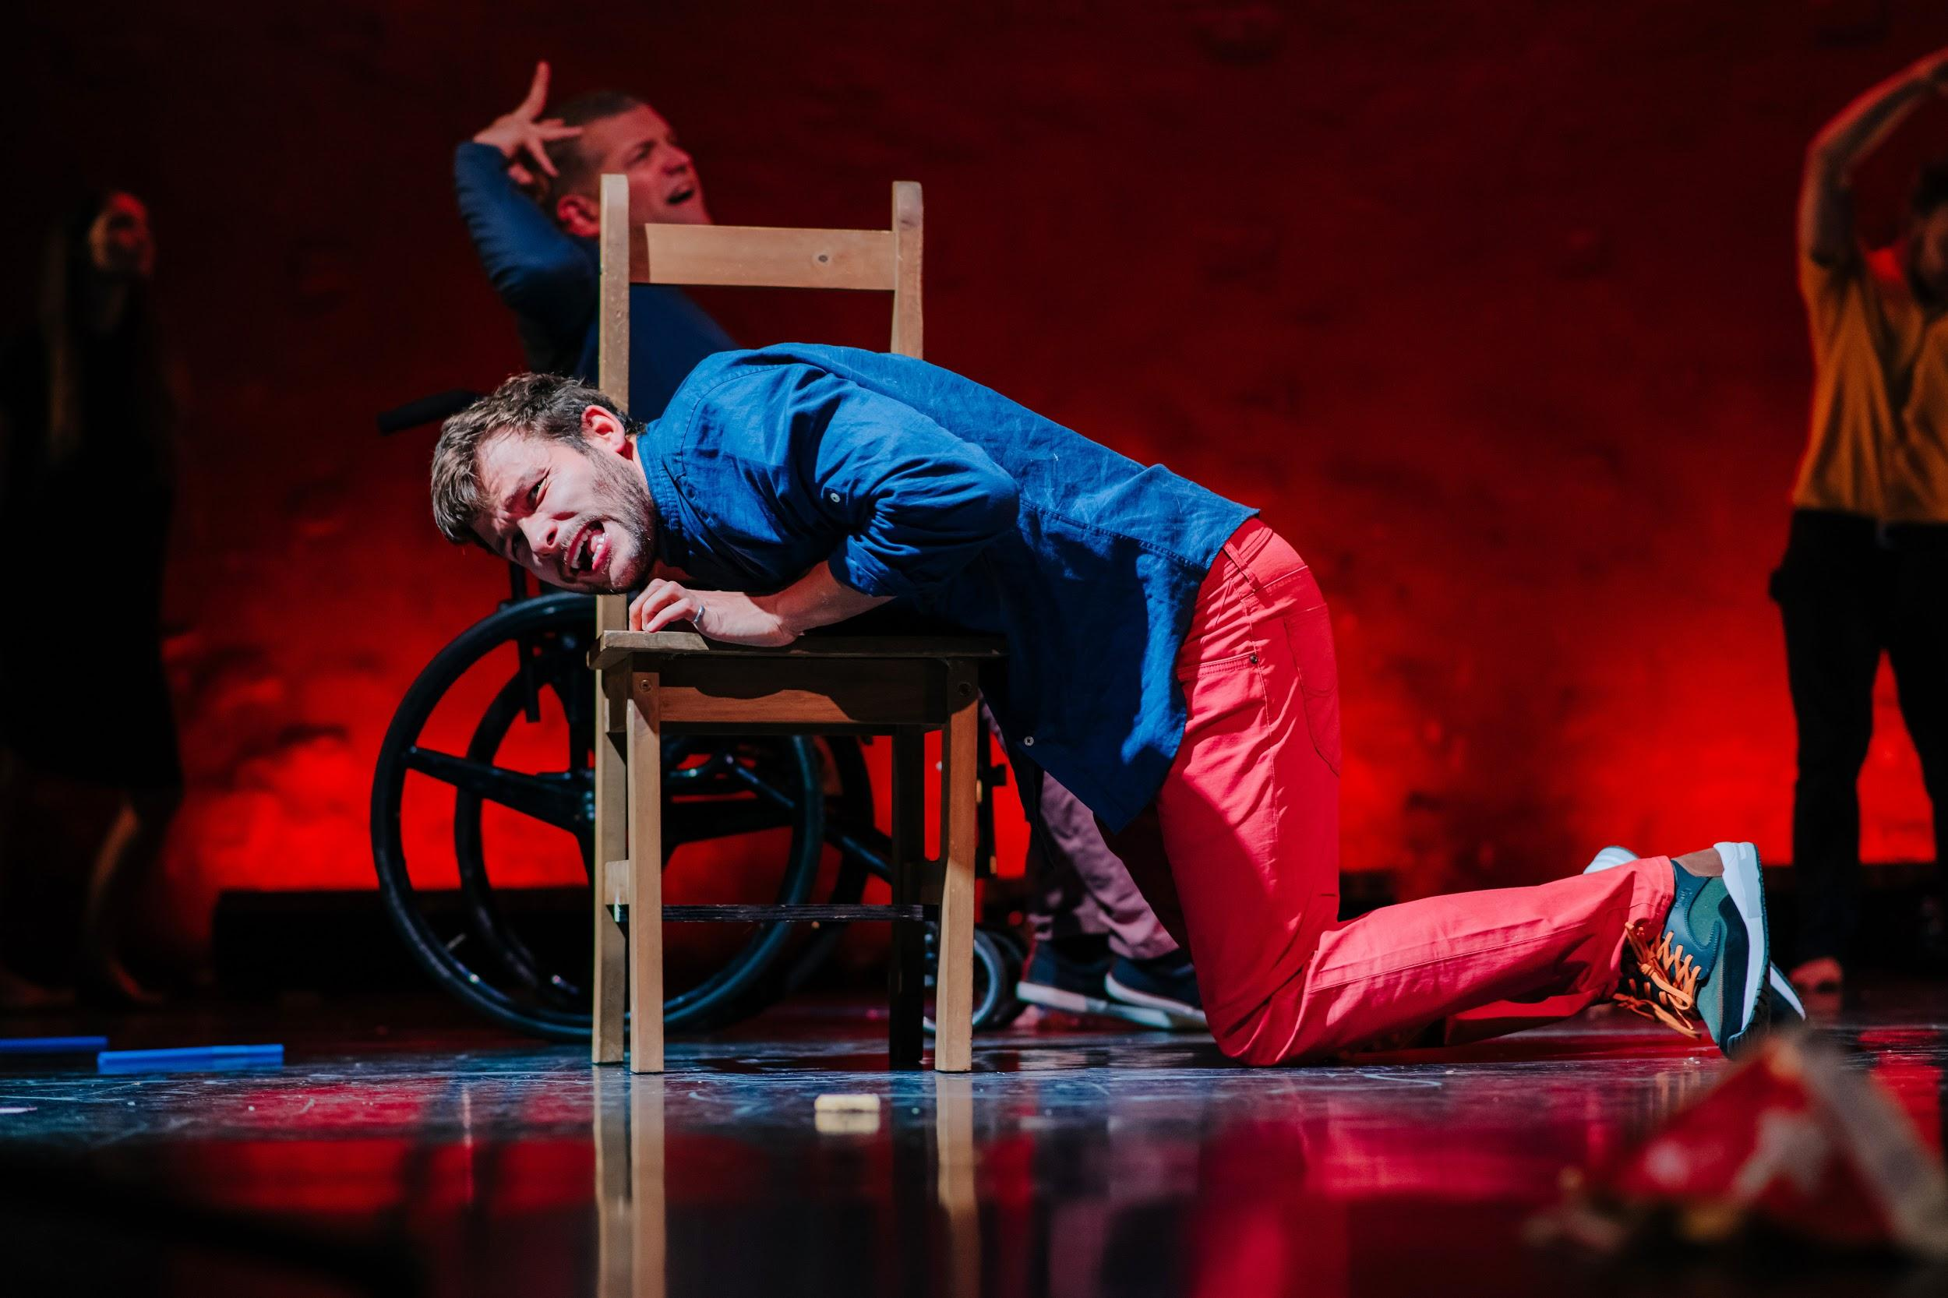

Phil beckons Amy over and repeat the section of dressing and eating from before.

They line up at the back of the stage just the same as at the beginning. It goes black and then bright light glares from behind them, casting them in complete silhouette.

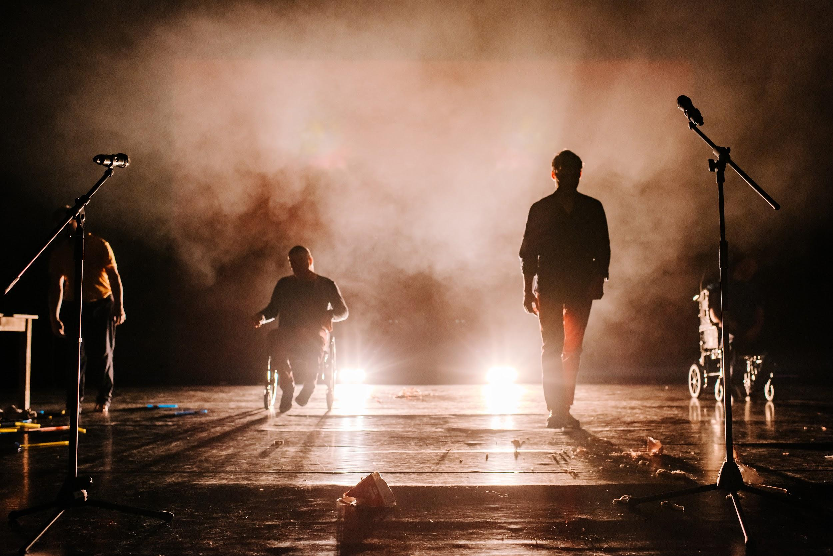

They move slowly forward, eventually reaching the mics. Pete is the last to arrive. Phil speaks first.

THE END

Feedback:

www.boptheatre.co.uk/feedback
all@boptheatre.co.uk

