BOP Young Artists Event: Creating a Quiet Space

On the 18th of December 2019, BOP young artists produced a Scratch Night event in collaboration with the BOLD collective. The event was hosted at the Scottish Youth Theatre in Glasgow. In order to make the event as inclusive and accessible as possible BOP worked with Max Alexander (Play Radical) to design and facilitate a Quiet Space for the evening. A ‘Quiet Space’ is a space designed to make places and events more accessible to people who are autistic and/or have sensory needs which make it difficult to access public spaces. It’s somewhere someone can go if they need to escape, avoid getting overloaded or rest and recharge.

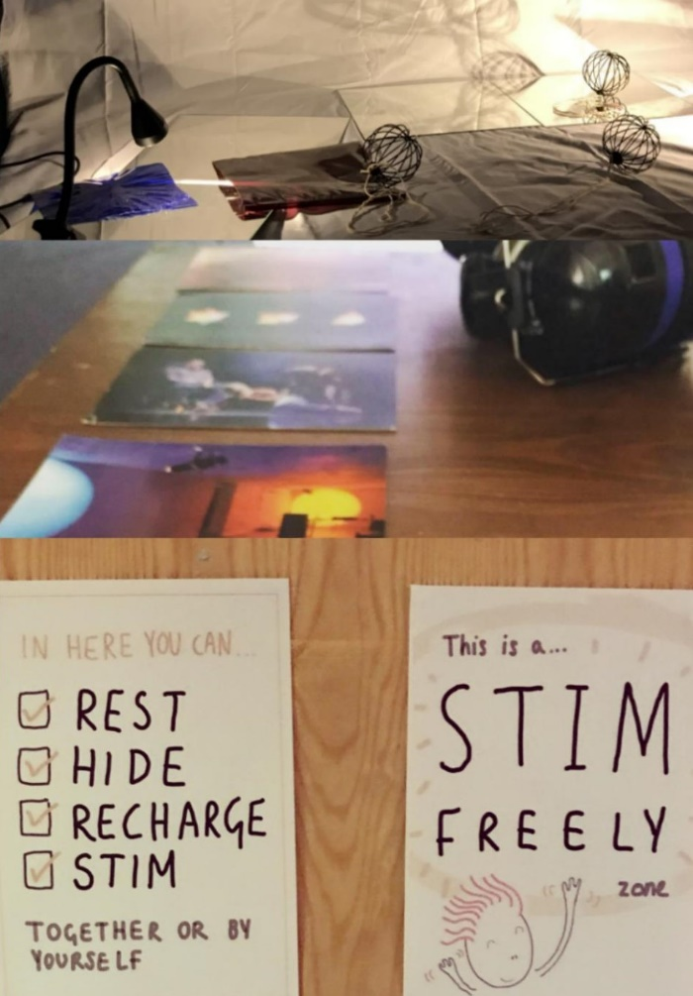
What needed to be considered?

1. Can you escape sensory input?
The space had to enable people to dull or block out or escape
sensory input that they were finding overwhelming or difficult.

2. Can you seek out sensory input?
The space needed ways for people to get sensory input they
found calming and/or enjoyable

3. Does the space feel safe and inclusive?
It was important to make sure that people who might need
the space would be able to access it whilst feeling as safe and
comfortable as possible.

4. Is it physically accessible?
People using wheelchairs and/or experiencing restricted
mobility needed to be able to get into the space and move
around it. Supportive seating needed to be available.

5.Does it feel like part of the wider event?
It was important that the space provided respite from the
general event but still felt like part of the overall experience
rather than something separate.

What did we do?
We were creating a temporary space in a room which usually functioned as an office, this added an extra level of designing and adapting to the process.
The actions we took to make the space as effective as possible can be spilt into three categories;
Adjustments: these are changes we made to the existing space
Additions: these are materials and resources we bought into the space
Facilitation: Having someone present in, or if necessary, outside, the space during the event to be a flexible element able to respond to peoples needs in the moment. The signage we used in the space was also a part of this as it was another way of giving people permission to use the space in the way they needed it.

Adjustments:
- Cleared the space moving furniture out of the way and any extra clutter. Made sure that the space at the entrance was open and obstructed.
- Removed squeaky cushions from armchairs and replaced with non-squeaky ones, covered up clashing colours and textures with soft muted blankets.
- Switched off fluorescent lighting and used soften lamps and hidden strip lights to provide non-direct light source.
- Covered up some of visual clutter from the bookshelves and surfaces.
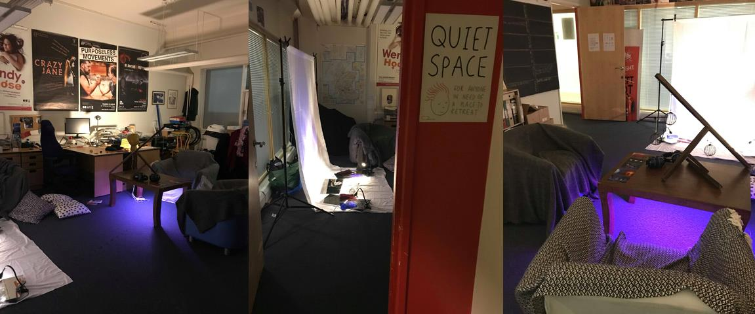

Additions
- Provided sensory adaptations such as ear defenders, a weighted blanket and fidget/stim toys
- Extra non-prescriptive sensory objects such as spinning baubles and BOP performance postcards. These added a contemporary feel to the space which reflected the event.
- Added extra cushions and blankets on the chairs and floor.
- Created and interactive light/shadow station using mirrors, a photo back-drop stand, fabric, coloured acetate and lights. This had multiple purposes; it created a light source and visual focal point for the room, it created an extra barrier between the room and the corridor outside and it enabled sensory play and exploration whist maintaining a relatively calm environment.

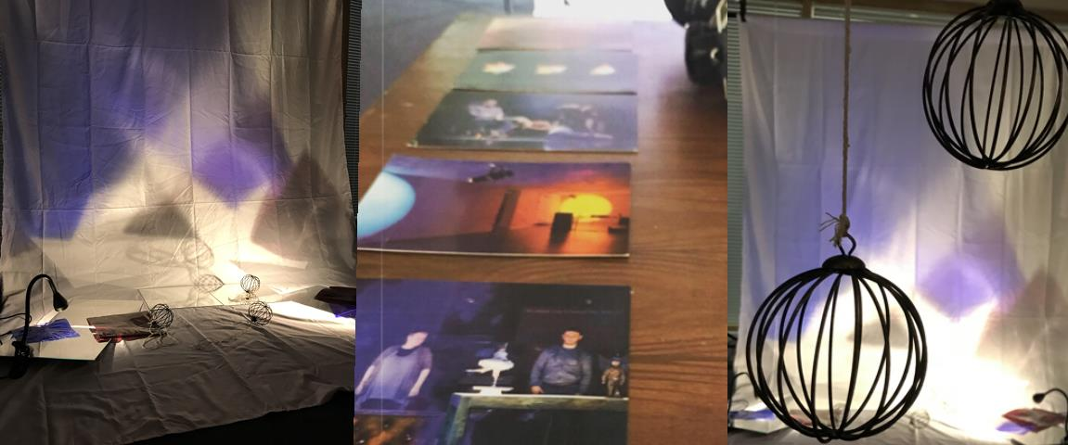

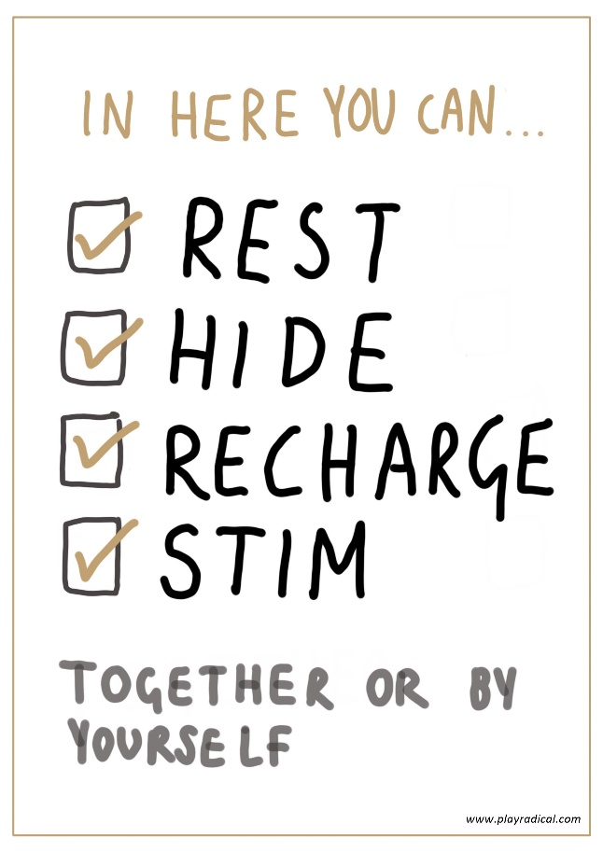
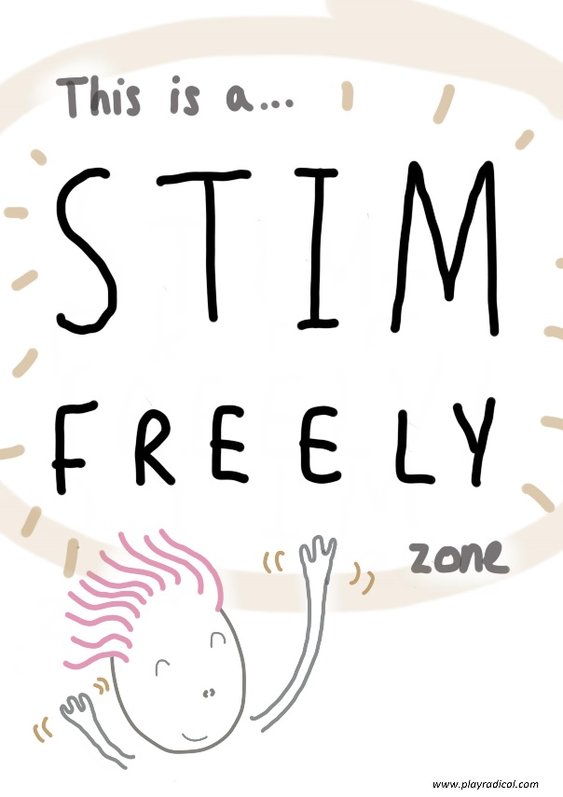
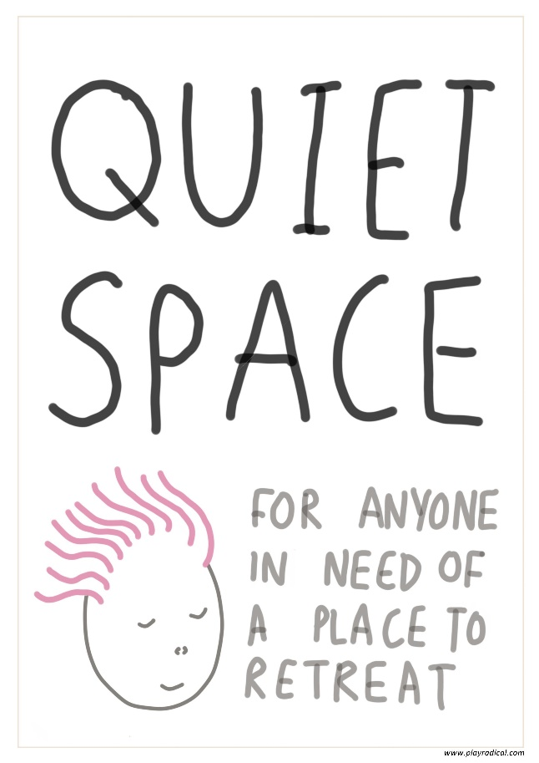
Facilitation: Visuals
The quiet space sign was used to direct people to the space and were posted around the building as well as at the entrance to the space.
The ‘Stim Freely’ and ‘In here you can…’ signs were displayed within the space providing instruction and permission to use the space as needed.

